Restorative Justice Trainers
&
2017 Funding Application

Index

Restorative Justice Background.......................................................Page 3

Trainers

Illinois Balanced and Restorative Justice……………………...….......Page 4

Nehemiah Trinity Rising…………………………………………………………Page 5

Circles & Ciphers.......................................................................Page 5

Community Justice for Youth Institute………………………………..…Page 6

2017 Restorative Justice Funding Application.................................Page 7

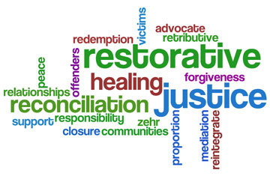

What is restorative justice? (from IBARJ)
Restorative Justice (RJ) is a philosophy, set of practices and mindset that addresses injustice (most often a law or rule broken) by thinking about the harms, needs and obligations of all of those involved. Healing is accomplished most often when all those affected are involved and meet to discuss and decide how best to repair the harm by addressing those needs and obligations.

There are Five Essential Characteristics of successful restorative practices:
- RELATIONSHIPS: Developing caring connections and finding common ground
- RESPECT: Listening to others’ opinions and valuing them
- RESPONSIBILITY: Being accountable for actions taken
- RESTORATION: Repairing harm that has been caused
- REINTEGRATION: Ensuring all remain included and involved

Why is restorative justice important? (from Nehemiah Trinity Rising)

Restorative justice recognizes the value that each person brings to a particular community. The processes used to build or restore relationships help to alleviate behavior and reactions to behavior that are destructive to individuals or community by fully identifying and addressing underlying issues.

Resources for Higher Ed Justice Information:
- http://blogs.roosevelt.edu/mansfield/
- http://scholarworks.uvm.edu/cgi/viewcontent.cgi?article=1021&context=tvc
- https://www.skidmore.edu/campusrj/documents/tedwatchelandstaceymiller.pdf

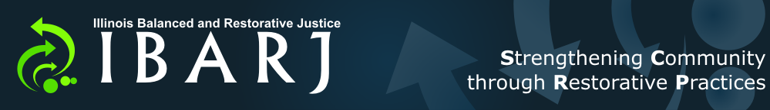
Illinois Balanced and Restorative Justice (IBARJ)
www.ibarj.org

Sara Balgoyen, Executive Director
PO BOX 8101 Champaign, IL 61826
Cell: 217-778-3351
sarab@ibarj.org

The Illinois Balanced and Restorative Justice Project (IBARJ) is a 501(c)(3) organization that seeks to expand and sustain the availability of balanced and restorative justice practices and programs for citizens of Illinois through leadership, education, and promotion. We are a vibrant network of professionals, volunteers, and organizations working locally, regionally, and statewide to create safer communities and schools, support victims, and improve pro-social skills and positive outcomes for Illinois youth. Our collaborative network includes leaders in juvenile justice, schools, social services, corporations, small businesses, communities, and faith-based organizations.

Trainings offered:
- First Consultation/Exploration of needs & possibilities (1 hour, no charge)
- Restorative Practices 101: An Introduction & Overview (2 hours, $300 plus trainer travel)
- Circles in the Classroom (1 day, $1200 plus trainer travel)
- Circles & Restorative Conversations (2 days, $1200/day plus trainer travel)
- Peace Circle Training (3 days, $1200/day plus trainer travel)
- Conference Training (2 days, $1200/day plus trainer travel)
- Peer Conference Training (1 day, $1200 plus trainer travel)
- Relationship Building Circle for Staff (3 hours, $400 plus trainer travel)

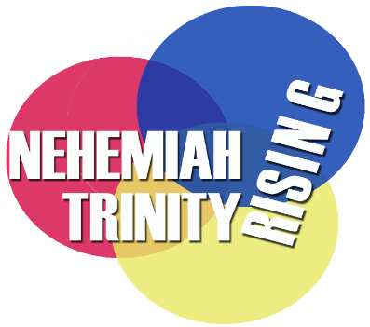
Nehemiah Trinity Rising
www.nehemiahtrinityrising.org
M. Michelle Day
9315 S. Longwood, Drive
Chicago, Illinois 60643
312.852.8520
mday2@sbcglobal.net

Nehemiah Trinity Rising – is a faith based, 501(c)(3) corporation dedicated to building peace. We provide education about restorative justice practices, skills for using such practices and develop relationships for implementing such practices in different settings (schools, businesses, churches, detention centers, prisons, homes etc.) as a way of transforming relationships, changing mindsets about conflict and healing our communities. We have members providing services to: Schools, Corporations, Returning citizen agencies/facilities, Churches, Prisons and Community Organizations.
Trainings offered:
- Conflict Transformation Introduction & Skills Building (1 day workshop)
- Introduction to Restorative Justice (2 hour session)
- Introduction to Restorative Conversations (half day or full day workshop)
- Four Day Peace Circle Training
- Restorative Leadership (1 day)
- Racial Equity Leadership (4 days)
- Ministry of Hospitality

Circles & Ciphers
http://www.project-nia.org/circles-and-ciphers.php
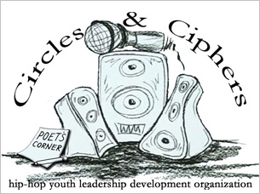
Evan
circles.ciphers@gmail.com

Circles and Ciphers is a leadership development program for young men who are in prison, court, and gang involved. Through the use of improvisational hip-hop freestyle ciphers, as well as talking and peacemaking circles, participants will respond to this tragic pattern as community organizers: they will design a new, autonomous, nonviolent gang tailored to their unique needs.

Community Justice for Youth Justice
http://cjyiorg.publishpath.com/

Ora Schub
Ora@cjyi.org
2929 S. Wabash, Suite 203
Chicago, IL 60616
312-842-5345

In 1997, two long-time child law attorneys on the faculty at Northwestern University School of Law’s Children and Family Justice Center, developed Community Panels for Youth. It is the first juvenile court diversion program in Chicago based on restorative justice. The attorneys expanded the program into eight Chicago communities. They eventually decided it was time to form an independent organization. With the support of Northwestern, the Community Justice for Youth Institute (CJYI) was incorporated in Illinois in October of 2003. CJYI became an independent 501(c)(3) non-for-profit corporation in June of 2006. The organization currently has four full-time staff members and works in close collaboration with a number of local and national restorative justice trainers.

Trainings offered:
- Initial meeting to discuss community or organizational needs (no charge)
- Introduction to Restorative Justice (2 hour workshop, $500)
- Introduction to Peacemaking Circles (1/2 day or full day workshop, $750 or $1,500)
- Four day Peacemaking Circle Keeper Training ($500/per participant)
- Organizational Four-day Peacemaking Circle Keeper Training ($10,000, up to 20 participants)
- Technical Assistance: cost to conduct a follow-up session for circle keepers ($750)
- Circle Facilitation (1-2 hour or full day, $500 or $1,500)

Restorative Justice Funding Application
February 2017 – December 2017
Illinois Campus Compact is offering financial assistance to schools that would like to pursue further opportunities to explore Restorative Justice on their campus. The goal is to help enable a school’s team to better discuss, address, and implement restorative justice practices on their campus.
This money can be used to bring in outside trainers to your campus, send students, staff, or faculty to a restorative justice training, or to enhance existing programs on your campus. Institutions may apply for up to $2,000.
Institution Name:

Team Members Name, Position and Contact Information (Please indicate team lead):

How does the team envision restorative justice as a tool on your campus?

What goals are most important for your team to accomplish with additional training?

Please let us know anything else about your institution that you think is relevant to this application.

Budget:

Please complete this application by March 10, 2017 and email it to aludwig1@depaul.edu.

